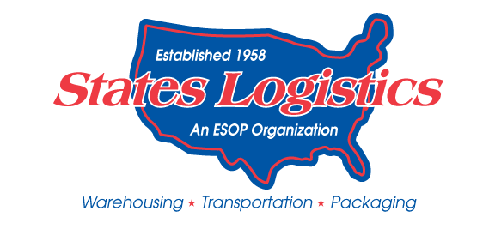
2023 Holiday Schedule
Below are States Logistics Services, Inc. designated holidays. Any associate who has a shift start on a designated holiday based on their work schedule, will receive 1 ½ times their regular rate of pay. Please note that while SLSI designates the holidays below, associates may be required to work on the designated days based on customer demands and volume.

Monday – Friday Work Schedule

January 2, 2023 (Monday) New Year’s Day
May 29, 2023 (Monday) Memorial Day
July 4, 2023 (Tuesday) Independence Day
September 4, 2023 (Monday) Labor Day
November 23, 2023 (Thursday) Thanksgiving Day
November 24, 2023 (Friday) Day after Thanksgiving
December 22, 2023 (Friday) Christmas Eve
December 25, 2023 (Monday) Christmas Day

Sunday – Thursday Work Schedule

January 1, 2023 (Sunday) New Year’s Day
May 28, 2023 (Sunday) Memorial Day
July 4, 2023 (Tuesday) Independence Day
September 3, 2023 (Sunday) Labor Day
November 22, 2023 (Wednesday) Thanksgiving Day
November 23, 2023 (Thursday) Day after Thanksgiving
December 24, 2023 (Sunday) Christmas Eve
December 25, 2023 (Monday) Christmas Day

Tuesday – Saturday Work Schedule

December 31, 2022 (Saturday) New Year’s Day
May 30, 2023 (Tuesday) Memorial Day
July 4, 2023 (Tuesday) Independence Day
September 5, 2023 (Tuesday) Labor Day
November 23, 2023 (Thursday) Thanksgiving Day
November 24, 2023 (Friday) Day after Thanksgiving
December 22, 2023 (Friday) Christmas Eve
December 23, 2023 (Saturday) Christmas Day

